Name | Ndongla Roy Longpi
department | Computer networking and cybersecurity
task | Penetration Testing

Penetration testing on Metasploita
Reconnaissance is the first stage of a penetration test. The goal is to gather basic information about the target before attempting any exploitation.
Metasploitable2, it is a deliberately vulnerable virtual machine used for learning and practicing cybersecurity and penetration testing.
- In our lab, Kali Linux was used as the attacker machine and Metasploitable2 was the deliberately vulnerable target.
The penetration testing was carried out as followed
Port scanning and vulnerability identification (under linux)
Firstly their Ip addresses were been identified by entering the commands on linux
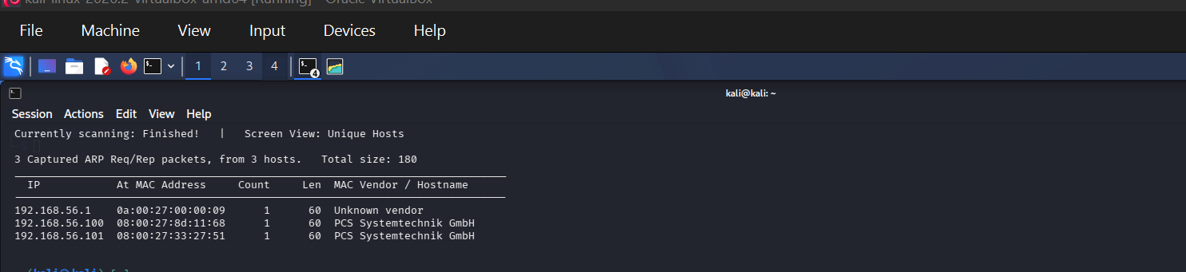

I tested communicatively between them which gave this outcome indicating there is communication.
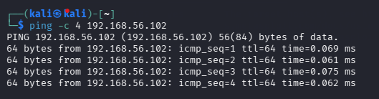

After that, the next I did was to determine the network services exposed by metasploitable which gave me the following available free ports. By performing a comprehensive scan.

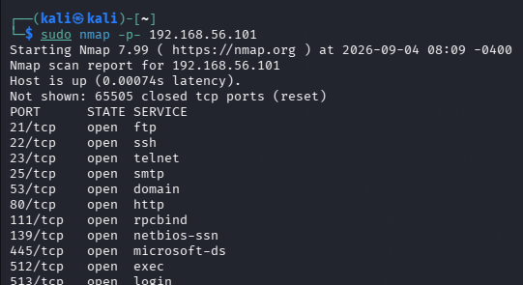
The next step I did after identifying the ftp ports was to identify their service version.
Through this I was able to discover their services such as their ftp service
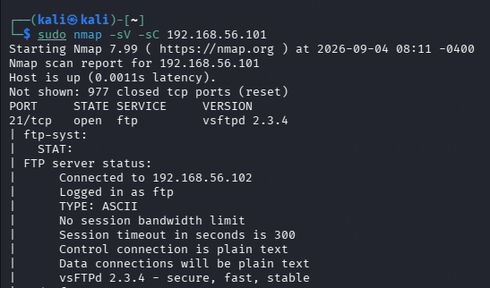
After discovering the services, I looked for versions known to contain security vulnerabilities.
The versions containing vulnerabilities which I discovered was:
I also obtain a version is associated with a known backdoor vulnerability, making it an appropriate candidate for further testing in this deliberately vulnerable environment
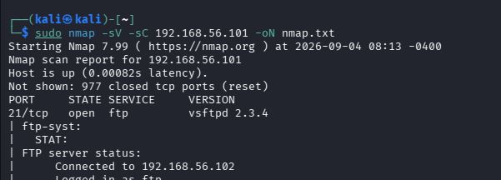

After that I verified the service form Kali is using, which also provided additional evidence that the vulnerable version was actually running.
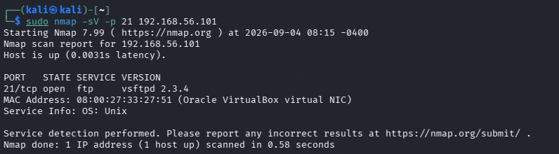

Exploitation Using Metasploit
Once the vulnerability had been identified, i used Metasploit Framework from Kali to test whether the vulnerability could be exploited.
Firstly, I ran the msfconsole to obtain the Metasploit framework, through which I was able to pass the following commands.
After entering the msfconsole to obtain the Metasploit framework it directly gave the vulnerabilities and the relevant module.
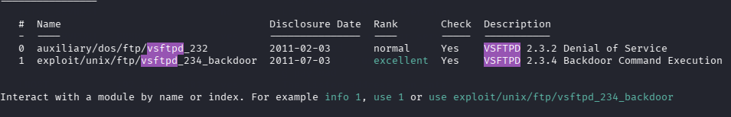

Then I specified the authorized targets:
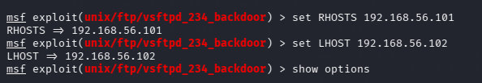
Finally, after specifying my targets, I executed the exploit on the isolated lab. The purpose of this stage is to determine whether the identified vulnerability can actually provide unauthorized access.
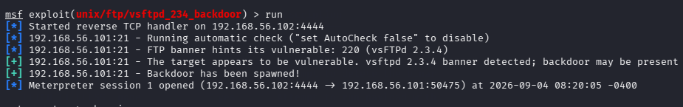

Proof of Access

since exploitation was successful and shell was obtain I then ran a few command which indicated which session was active wish also acts like as proof to the fact that target was actually accessed.

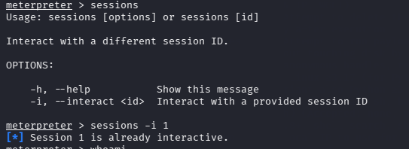
After that a few commands are entered inside the resulting target shell, which provide evidence about account obtained, target computer and privileges.
